**Question 1**

**1.**



Figure navbar

What’s the difference between the following display values: inline, block, inline-block?

* Display inline like span and anchor tags .. they don’t take any width or height and it’s overflow on other items when apply padding on it, they appear on the screen beside each other.
* Display inline-block like images … It appear beside each other in the page like inline and also can take width and height and other properties that inline did not take.
* Display block like div , header , section , footer and other semantic tags it takes the full width of the page and it takes width and height, it appear under each other in the page.

Figure navbar hover

**Question 2**

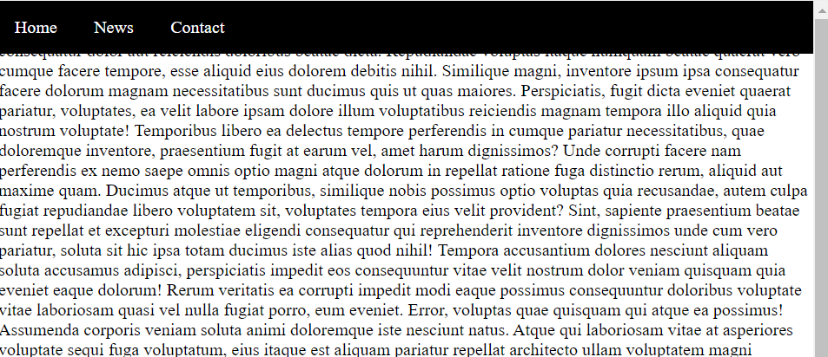**1. Position fixed**

Figure 3 fixed navbar

**2. position sticky**

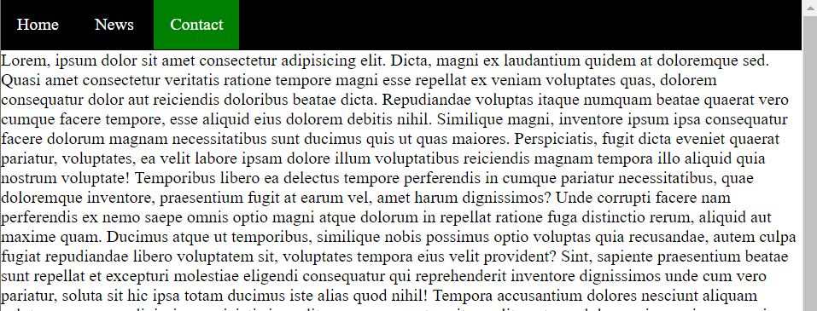

Figure sticky navbar

The difference between fixed and sticky is that fixed is become on the top of the text but sticky makes the text starts from under the navbar …. We can consider the navbar fixed as a layer on the top of the page but sticky on the same layer.

Question 3

1. Text on image



Figure text on image

1. Flex Question

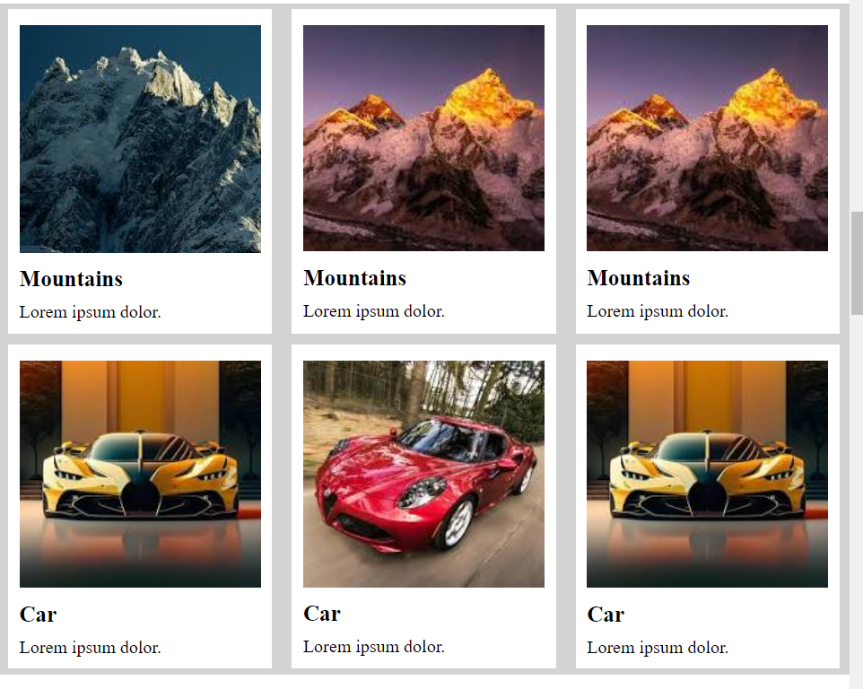

Figure flex

3.3 drop down menu

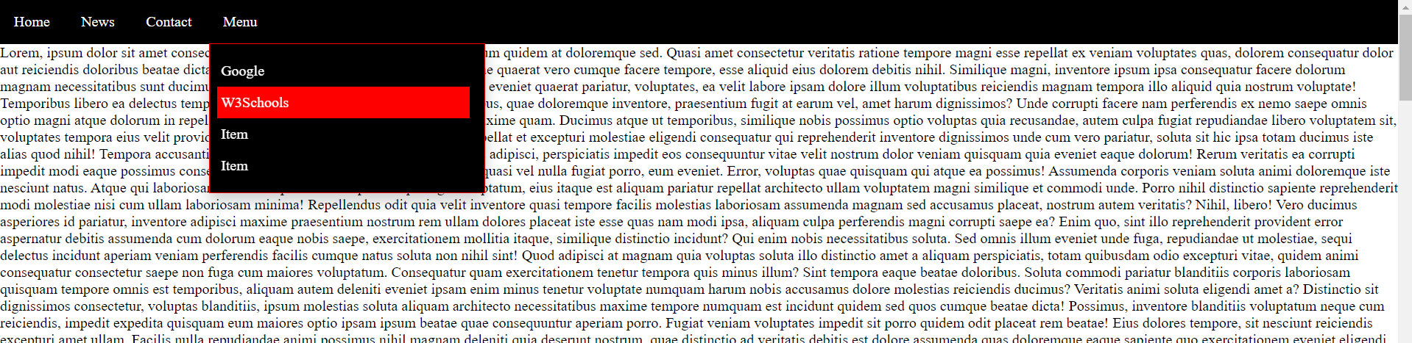

Figure dropdown menu